
October 2024

Thank you very much for your support of the Cloquet Educational Foundation! Our goal is to provide important learning experiences for Cloquet’s children and youth. We are so happy you have agreed to be a table sponsor for the 23rd annual Blue Jean Ball, which is scheduled for Saturday, February 1,2025 at 5:00 p.m. in the Otter Creek Ballroom at the Black Bear Casino Resort. The cost to sponsor a table is $125. Your contribution is greatly appreciated and helps to ensure another successful FUNdraising event. The Cloquet Educational Foundation is a 501c 3 non-profit organization, and all gifts are tax deductible (Tax ID #41-1543092).

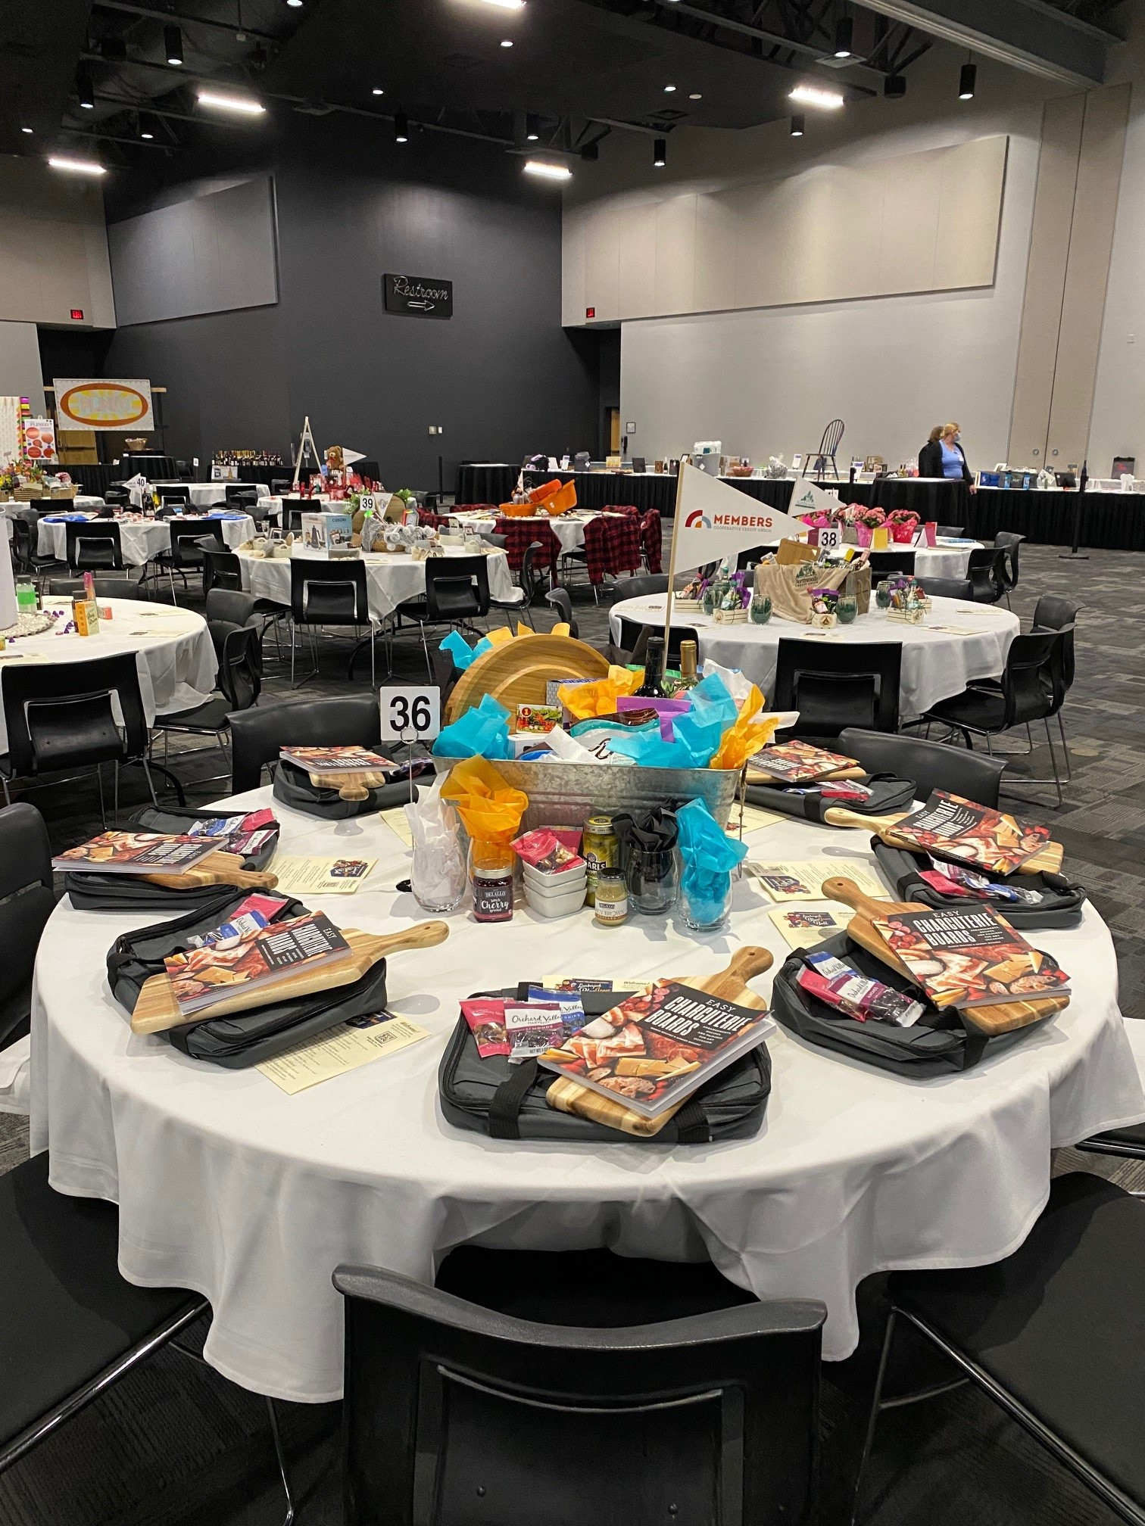
As a reminder, table sponsors are responsible at an additional cost, for providing a centerpiece and items for a table that seats eight guests. These promotional items help to showcase your business. At the end of the evening, guests sitting at your table are given the items you use to decorate your table as a gift from you. In addition, one lucky person will also have a chance to win your centerpiece (if you are unable to provide a centerpiece, please let us know so alternate arrangements can be made). These giveaways serve as a reminder of your business’s support and generosity—and are a fabulous way increase visibility for your business.

Although table sponsors are responsible for decorating their table, if you need assistance please feel free to contact any of us. We will be at the Otter Creek Event Center between 10:00 AM and 4:00 PM on Friday, January 31st to help you in any way needed. If you are unable to decorate your table on Friday the 31st, please let us know as soon as possible so we can make alternate arrangements. Please note: Black Bear does NOT allow helium filled ballons as decorations.

Benefits for table sponsors include:
- Public recognition at the Blue Jean Ball in the program and by the Master of Ceremony
- A colorful sign with your business name and logo identifying you as a sponsor
- Recognition as a table sponsor is posted on the CEF website and on Facebook
- Table sponsors are acknowledged in the spring CEF newsletter
.
We also hope you will be able to attend this year’s Blue Jean Ball. We still have tickets left, but they are going fast! The cost per ticket is $50.00. If you would like to purchase tickets or if you have any other questions, please feel free to contact us using the information below. We are able to include ticket purchases on the invoice that we will send out in a few weeks.

Looking forward to seeing you!
Sincerely,

Mary Jane Lundberg, Sarah Buhs, Jen Owens & Jody Acers
Blue Jean Ball Table Sponsor Committee
218-879-3806email: jacers@isd94.org

